**Weather Station Build**

**Materials:**

Temperature/Humidity sensor

BME20

DHT220

WiFi enabled Microprocessor

ESP320

Anemometer

DC motor

The BME280 Barometer Module is an easy way to measure barometric pressure, humidity, and temperature readings all without taking up too much space. Basically, anything you need to know about atmospheric conditions you can find out from this tiny breakout. The BME280 Breakout has been designed to be used in indoor/outdoor navigation, weather forecasting, home automation, and even personal health and wellness monitoring.  
  
The on-board BME280 sensor measures atmospheric pressure from 30kPa to 110kPa as well as relative humidity and temperature. The breakout provides a 5V tolerant I2C interface (with pull-up resistors to 3.3V), takes measurements at less than 1mA and idles less than 5µA.

**Features:**

* Operation Voltage: 3.3V
* IIC Communications Interface
* Temp Range: -40℃ to 85℃
* Humidity Range: 0 - 100% RH, =-3% from 20-80%
* Pressure Range: 30,000Pa to 110,000Pa, relative accuracy of 12Pa, absolute accuracy of 100Pa
* Altitude Range: 0 to 30,000 ft (9.2 km), relative accuracy of 3.3 ft (1 m) at sea level, 6.6 (2 m) at 30,000 ft.

**Package List:**

* 1 x BME280 Barometer Module

**Documents:**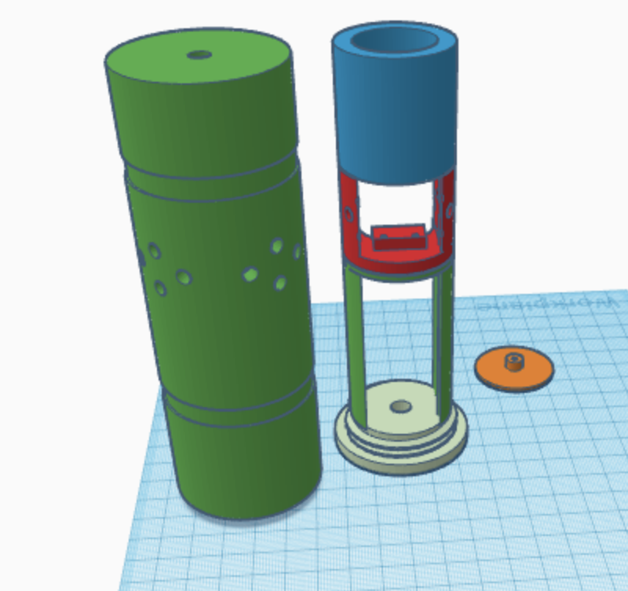

* [Datasheet](https://www.makerfabs.com/desfile/files/BST-BME280_DS001-10.pdf)
* [Arduino Library](https://github.com/sparkfun/SparkFun_BME280_Arduino_Library)

